SYLLABUS

Business Law Course Outline/Fall Syllabus - (Bus 110 Section 1) Mondays 6:00– 8:50 p.m. MVS Decision Center
Textbooks: Required: Jennings - Foundations of the Legal Environment of Business, Second Edition
Highly Recommended: Joshua Greene - Moral Tribes: Emotion, Reason, and the Gap between Us and Them

INSTRUCTOR: Panda Kroll, email: panda.kroll@csuci.edu, tel. 805-551-0773
Office Hour: Mondays 5 pm Sage Hall 2038 or by arrangement

Date | Topics To Cover In Class | Reading & Homework Due Before Class Begins
1/27 | I. The Legal Environment in Which We Live  II. “Truthiness” v. Critical Thinking  When Is An Act Legal/Illegal?  Is Cannabis Illegal? Is Porn Legal?  How to: Succeed in This Class  The Socratic Method: Q&A  (Applying legal rules to fact patterns)  Video: Age of Consent  Sign up for Moral Tribes weekly presentation | MODULE I – WHY HAVE LAWS AT ALL?  Before Class:  Review Assignments posted in Canvas  Answer Survey  Complete Study Guides: CANVAS #1A & 1B  Sex & Drugs @Work  - Read articles posted on Canvas  (Ma & Pa cannabis business, porn@work)  ALLOW 4-6 HOURS TO COMPLETE ASSIGNMENT – this will be true each week, so plan accordingly  Please do not turn in homework in class.
2/3 | III. Sources of Law  Statutes & Judicial Decisions  When Is An Act Legal/Illegal?  Is Cannabis Illegal? Is Drug Testing Legal?  Video: Supreme Court oral arguments in Ross | MORAL TRIBES: Part 1-Moral Problems  Intro, Chapter (Ch) 1: The Tragedy of the Commons  Read Case Study posted in Canvas:  Ross v. RagingWire  (medical cannabis @work)  IN-CLASS QUIZ ON ROSS v RAGINGWIRE
2/10 | IV. Sources of Ethics:  What If There Were No Laws?  What If The Laws Are Unfair?  Sex Laws:  Were Romeo & Juliet guilty of sex crimes?  Obscenity Laws:  Is rap music obscene?  What is “sexting,” and is it child pornography?  Video: Teens Accused of Sexting Fight Back | MORAL TRIBES  Ch 2: Moral Machinery  Take Home Quiz/Study Guide: CANVAS #2A & 2B  Sex Laws  - Sexts – Pornography? Obscenity?  - Rap Music  Be prepared to discuss:  “How did the teens defend themselves from the threat of state criminal charges for child pornography arising from their use of their cell phones?”
2/17 | Cyber-Crime & Punishment:  Civil Liability and Criminal Guilt  for Emails and Facebook Postings  How to:  • Regulate “new” torts/crimes  - Distinguish criminal from civil law  - Manage your online reputation  Video: MySpace Suicide: Witness Testimony | MORAL TRIBES  Ch 3: Strife on the New Pastures  Take Home Quiz/Study Guides: CANVAS #3A, B & C  Cyber Laws  - Privacy & Reputation on the Internet  - Virtual Lives/Real Consequences:  - The MySpace Suicide Case  UPLOAD Answer to Case Study:  E-Mail Trouble On the Job
2/24 | Litigation in Our Judicial System:  How Does A Lawsuit Begin? Which Facts Matter?  What is the Truth and Who Decides?  What 2 Do When U Want 2 Sue and  How 2 Prove Your Case  How to:  • Write/respond to a “demand” letter  • Decide whether to litigate  • Avoid Evidence “Spoliation”  Exercise: Litigation Flowchart | MORAL TRIBES: Part 2-Morality Fast & Slow  Ch 4: Trolleyology  MODULE II – “SEZ WHO?”  “NastyGrams,” Evidence in Litigation  Take Home Quiz/Study Guides: CANVAS #4A & 4B  Read Jennings, Ch. 3 selected pages:  - Analyze Exhs. 3.1, 3.2, 3.3, 3.6 and esp. 3.9  - Read at least pages pp 67-77 in Ch. 3  UPLOAD Answers to Jennings Case 3.3  Wal-Mart Stores v. Johnson “Reining Deer,” pp. 73-74
3/2 | CONSTITUTION TEST (open book)  Federal & State Constitutional Controversies  Which Laws Are “Fundamental?”  Bill of Rights/Equal Protection/Due Process  • Declaration of Independence  • Racial Inequality in Land Ownership  Students’ Rights  T-Shirt Wars  Bathroom Wars  How to:  Use the 14th Amendment offensively to protect individuals from discrimination based on membership in a protected class  How to:  Use the 1st Amendment offensively to protect  pro-drug/pro-choice/anti-gay messages  How to:  Understand how judges resolve cases involving competing rights (property rights, free speech, religious freedom and equal protection, on the one hand, and privacy, safety, and a school’s “educational mission” on the other) | MORAL TRIBES  Ch 5: Efficiency, Flexibility, & The Dual-Process Brain  BRING JENNINGS TO CLASS FOR OPEN BOOK TEST  Read Jennings, Appendix A (US Constitution)  Take Home Quiz/Study Guides: CANVAS #5A & 5B  MODULE II: Our Fundamental Rights  1) Constitution Study Guide  (not to upload but to prepare by filling in blanks)  2) Student Speech Controversies: T-Shirt Wars!  - Morse (Juneau School Bd.) v. Frederick  “BONG HiTS 4 JESUS” in SCOTUS  - Nuxoll v. Indian Prairie School Dist.  ”Homosexuality is Shameful”  Harper v. Poway School Dist.  “Be Happy Not Gay”  T.A. v. McSwain Union Elementary School Dist.  “Abortion Is Murder/Growing Growing Gone” –  SuperReader Presentations on Equal Protection  - Gloucester County School Board v. G.G.  School Bathrooms in SCOTUS  - Masterpiece Cakeshop v. Co Civil Rights Comm.  Cakes, Celebrations, & Discrimination in SCOTUS
3/9 | Constitutional Law, cont.:  Do Corporations Have 1st Amendment Rights?  How to:  Use the 1st Amendment defensively to avoid liability for controversial messages  Tort Law: Intro to Risk Allocation -  Who Should Pay For Careless/Criminal Acts?  Duty to Rescue  Elements of Negligence  - Duty  - Breach of Duty (Carelessness)  - “But For” Causation (Factual Cause)  - Proximate Cause (Legal Cause)  - Damages  Torts “Matching” Exercise  How to: Respond to requests for references | MORAL TRIBES: Part 3–Common Currency  Ch. 6: A Splendid Idea  MODULE III: The Law of Torts (Wrongs/Negligence)  Skim Ch. 8 (the entire chapter)  1) Study Guide: Reading/Qs Canvas #6A  (McCollum v. CBS/Ozzy Osbourne - wrongful death)  2) UPLOAD Answers to Canvas #6B - Randi W. (negligence/fraud)  3) UPLOAD Answers to Jennings, Case 8.3 - Van Horn  (negligence: duty issue, “Good Samaritan” defense)  4) UPLOAD Answers to Canvas #6C  (Jenny Jones murder case)
3/16 | Tort Law, cont.:  Are Laws Protecting Privacy & Reputations Consistent with The First Amendment?  How to: Avoid exploitation and defamation claims  Video: Eminem “Brain Damage”  QUIZ on IP (Intellectual Property) Law  Be sure you know and can apply the definitions:  A. Copyright & Fair Use  B. Trademark  C. Patent  D. Trade Secret  E. DMCA “Safe Harbor” Defense  Video: “Pretty Woman”  PUBLISH STUDY GUIDE FOR TEST I | MORAL TRIBES  Ch. 7: In Search of Common Currency  MODULE III – Reputation Torts & Intellectual Property  2) Study Guide: Reading/Qs Canvas #7A  - Bailey v. Mathers, III (a/k/a Eminem, Slim Shady)  - “Borat” complaint and pages of Panda’s article  3) Answer Jennings Case 14.2  (2 Live Crew)  Skim Ch.14 (the entire chapter); Study Exh. 14.1  4) Complete CANVAS #7B  - Trade Secrets – article explaining California law  - Viacom v. YouTube – article on $1B lawsuit  STUDY FOR QUIZ ON IP DEFINITIONS
3/23 | SPRING BREAK | Watch Borat film (in CANVAS)
3/30 | TEST I  Trademark and Fair Use  Product Liability/False Advertising  How to know: Know when advertising is “false”  How to know: Know when coffee is  “too hot”?  Video: “Barbie Girl”  Video: “Borat” mockumentary presentation | MODULE III – (cont.)  1) UPLOAD Answers to Canvas #8b  (McDonald’s hot coffee case)  2) Study Guide: Reading/Qs Canvas #8a:  Mattel v. MCA Records (The Plastic Plaintiff)  STUDY FOR TEST
4/6 | Intro to Contracts – Contract Formation  Sources of Contract Law: UCC – Common Law  How to: Know when a contract has been formed  How to: Know when a contract needs to be in writing (Statute of Frauds)  Video: “Pepsi Stuff”  Video: “Some Kind of Monster” | MORAL TRIBES: Part Four: Moral Convictions  Ch. 8: Common Currency Found  MODULE IV –The Law of Contracts : Part I (Formation) - “Did I Agree To That?”  1) CANVAS #9 (Fill-in-Blanks)  Common Law & UCC Contract Rules  Read Jennings Ch. 10 p. 230-232, 236-242, 247-249  Exhibits 10.3, 10.5; definition of contract p. G-5  2) UPLOAD Answers to Case 10.2 Leonard v. PepsiCo  (Does “Pepsi Stuff” Include a Harrier Jet?)  3) UPLOAD Answers to Case 10.5 Rosenfeld v Basquiat  (“The Artist, The Crayon, & the Contract” )  4) UPLOAD Answers to Case 11.2 Reed v. King  (The Haunted House)
4/13 | Contracts – Performance & Defenses  “Battle of the Forms”  What happens when businesses exchange  competing forms with different terms?  “Clickthrough” Agreements, Liability Limitations  Unconscionable Contracts  How to: avoid a warranty claim  PUBLISH STUDY GUIDE FOR TEST II | MORAL TRIBES:  Ch. 9: Alarming Acts  Ch. 10: Justice & Fairness  MODULE 4 –The Law of Contracts “ Part II (Defenses)  Read Jennings pp. 254-263, 267-68 Defenses/Remedies  Study Jennings Exhibit 12.2 - UCC Warranties  1) Case Study 11.3 A.V. v. iParadigm  (TurnItIn copyright case – first see “Consider” p. 255)  2) Quiz: CANVAS #10A  Mortenson Co v. Timberline Software  (The Two-Million-Dollar Bug) 5 pts + 20 E.C. option  3) CANVAS #10B  Fill in Blank Study Guide (UCC Warranty Provisions)
4/20 | Contracts – More Defenses:  Fraud/Misrepresentation/Lack of Capacity  How to: Set aside/avoid/rescind a contract  How to: Prevent contract “fraud” claims  TEST II  Exercises: GroupThink  Challenger Disaster & Whistle-blowers | MODULE IV –The Law of Contracts (cont.)  Getting Out Of A Bad Contract – Part 2  1) ANSWER CANVAS #11A: “Young Drugged & Wealthy”  When Defects Cost Lives: Whistle Blowers  Read Ch. 15, p. 365 (Protection for Whistleblowers)  2) CANVAS #11B: Cast Study The Challenger Disaster  STUDY FOR TEST
4/27 | Corporate Law  - Forms of Doing Business  How to:  • Form a sole proprietorship  • Form a partnership (without really trying)  • Limit liability, fund a business  Employment Law: Agency  How to: Restrict post-employment conduct  Know if you owe/ are owed overtime pay  PUBLISH STUDY GUIDE FOR TEST III | MORAL TRIBES: Part 5-Moral Solutions  Ch. 11: Deep Pragmatism  Ch. 12: Beyond Point-and-Shoot Morality  MODULE V – The Law of Corporations / Agency  Read Jennings:Ch. 18, pp. 410-426, esp. Exhibit 18.1  1) Answer Case 18.2 (Ma & Pa café)  2) Answer CANVAS #12A  (What are the different forms of business entities?)  Duties of “Agents” and “Principals”  Read Ch. 15 pp. 350-354, 356, 358  3) Answer CANVAS #12B (Oprah case)  Liability for Agent’s Mistakes  1) Answer Jennings Q’s: Case 15.3 (Cookie Crazy)  2) Answers Jennings Q’s: p. 367, questions #4 and #5
5/4 | Employment Law: Agency, cont.  Employer & Employee Liability  Employment Law: Employee Rights  Wage & Hour Laws | MODULE V – Employment Law  Illegal Discrimination & Retaliation in the Workplace  Read CANVAS #13 CA Employment Law  Read Jennings p. 399 (BFOQ), p.404-405 (ADA)  3) UPLOAD Answers to Jennings Case 17.3  (sex harassment)
5/11 | (“FINAL” – not cumulative)  Employment Law: Agency, cont.  Discrimination/Harassment/Retaliation  How to: Tolerate Intolerance | Religious and Gender Discrimination @ Work  1) UPLOAD Answers to CANVAS #14a:  Buonanno v. AT&T  (Conservative Christians’ right to disagree w/gay-friendly workplace policies)  2) Read Jennings “Consider” 17.3 on pp. 397-98  (“Church of Body Modification”)  STUDY FOR TEST
5/18 | TEST III  7:00-9:00 p.m.

RESOURCES: (a single copy of each of the two class textbooks is on reserve at the CSUCI Library)
Over half of your assignments are on myCI Learn/Canvas.

BUS 110: OVERVIEW OF COURSE AND COURSE EXPECTATIONS
Class Preparation: Plan for four to six hours of homework each week: 2 hours reading and re-reading assigned cases and articles and 2-4 hours preparing Case Questions and/or completing myCI Learn assignments, due each day before class begins. I have done my best to make the extensive homework worth your time, by choosing “hot” topics likely to arise in your work and daily life. You’ll get more out of class if you are prepared, and you will earn more “Preparedness” points.

Expectations:
You need your syllabus, textbook(s) and study guides each class. To maximize your experience, attend class, arrive on time, read and complete assignments, and “Opt In” to participate in class by answering questions.

Method of Student Evaluation:
Exam Score (best two out of three) 60%
Homework Score (Quizzes, Uploaded Assignments) 30%
Class Preparedness Score (Attendance, Opt In/Out of Discussions with ✓+ or -) 5%
Presentations on Moral Tribes 5%

Cut-Offs for Final Grade:
94% = A; 90% = A-; 87% = B+; 84%=B, 80% = B-; 77% = C+, 74% = C, 70% = C-; 67% = D+, 64% = D. Below 64% = F

Exam Score:
Exam Score is evaluated on your best score on two out of three multiple-choice tests. You will not need blue books or scantrons. There will be three multiple choice tests, based on lecture, readings, assignments and/or any topics discussed during class. I will provide a study guide prior to each test. There will be no cumulative final, although tests may include material discussed throughout the semester. I will exclude your lowest-graded test from your score. I will keep your tests and quizzes on file for only two weeks after the test or quiz is given. If you wish to go over a test or quiz, do so prior to that time. I do not give make-up tests; that is why I count only two out of the three tests.

Homework Score: Homework Score is evaluated on homework uploads due prior to class, and three in-class quizzes.
If you upload the homework assignment to Canvas after class begins, you will not receive any credit (no late homework).

Class Preparedness Score: Opt-In (“Plus/Check/Minus” Participation / Moral Tribes Presentation):
Class Preparedness Score is evaluated based your participation and presentations. You will prepare a collaborative presentation on a chapter from Moral Tribes. To prepare for class discussion of the articles and cases in Canvas and the textbooks, complete study guides and upload assignments. We will have class discussions in which I will ask you questions from the assignments. You can “Opt-Out” of discussions by claiming a minus and/or be absent up to three times with no effect on your participation grade. If you come in after roll is taken, I will mark you absent and as an “Op-Out” unless and until you meet with me after class to update the roll.

Course Format:
The best way to learn and to apply the law is to read about and discuss legal issues that affect us, applying critical thinking to find rational conclusions. For this reason, this is not a lecture-based class. Instead, this class requires substantial student preparation and participation. You will discuss your responses to assignments and apply what you have learned to hypothetical and real situations. You are responsible for checking Canvas each week for announcements, changes, clarifications and assignments, and for coming to class with assignments uploaded and study guides completed.

What is Critical Thinking?
This course focuses on applying critical thinking skills to solve ill-structured problems. To be successful in this course and in the job market, you will need to develop the capacity to evaluate skillfully and fairly the quality of evidence and detect error, hypocrisy, manipulation, dissembling (lies), and bias (prejudice). In other words, recognize “Truthiness.”
- Identifying issues and prioritizing which to address;
- Using evidence, experience, and values to analyze these issues;
- Managing uncertainty and risk; and
- Making rational decisions (i.e., finding the most productive solution that is sensitive to uncertainty & risk)

Program Learning Goals
- Critical Thinking
- Oral Communication
- Written Communication
- Collaboration
- Conduct (Ethics)
- Competency in Discipline (i.e., in Business)

Student Learning Outcomes/Course Objective:
The course objective is to provide students with practical knowledge of legal principles and issues that arise in business. Businesses are subject to employment and contract disputes, negligence claims, regulatory compliance, and other legal issues, yet many business owners and managers are ill-equipped to identify legal risks before they arise. Without legal sophistication, business cannot identify and implement strategies to prevent problems from occurring or, at least, from spiraling out of control. While litigation is an inevitable cost of doing business, it is controllable. Students will develop the ability to spot potential legal problems and manage risks, enhancing their marketability to the businesses that employ them, and increasing their effectiveness as entrepreneurs.

At the completion of this course, students will be able to:
- Describe the major components of the United States legal system (Learning Goals 2, 3, 5, 6);
- Write analyses of cases related to business organizations and their legal environments (1-6);;
- Research and present oral and written analyses of how laws and regulations impact business organizations (1-6);
- Identify, analyze, and suggest solutions for businesses to address their legal and ethical challenges (1-6).

Cheating, Plagiarism and Other Forms of Academic Dishonesty: Don’t copy another student’s assignment or test and don’t let another student copy your assignment or test. CSUCI characterizes its graduates as creative in developing imaginative self-expression and independent thinking and dedicated to maintaining principles of intellectual honesty. Academic dishonesty is incompatible with these characteristics. Accordingly, you are expected to complete your own work, and you will be subject to sanctions if you cheat or assist others in cheating. If a student is suspected of submitting work containing word-for-word or closely paraphrased language from another student’s work, OR if a student is suspected of assisting another student in copying, both student(s) will receive no credit for any such suspected assignments//tests and will be reported to CSUCI’s Judicial Affairs for adjudication / sanctions, up to and including a failing course grade. See http://www.csuci.edu/studentlife/student-conduct/academic-dishonesty.htm.

Students with Disabilities needing accommodations, please make requests to: Disability Accommodation Services
Phone: https://www.csuci.edu/dass/. Please discuss any approved accommodations with the professor as soon as possible.

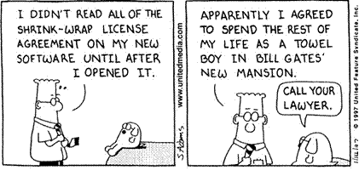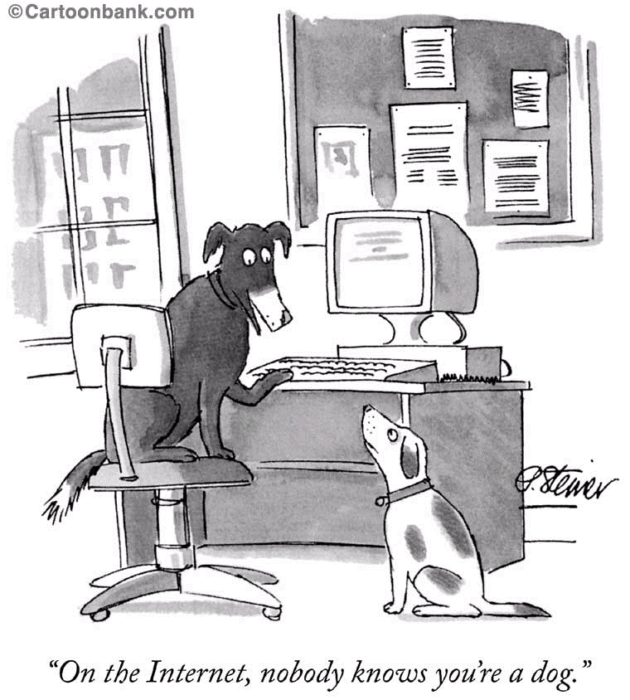

(Examples of private law - invalid racially restrictive covenants in a real property deed)



