Accounting 300 – Online – Applied Managerial Accounting –
Syllabus
FALL 2021

Instructor: Karen Anna Papazian, MBA

Class Meetings: Online

Zoom Office Hours: Wednesdays, 5:30 – 6:30pm
and by appointment

Zoom Classroom: https://csuci.zoom.us/j/7315685727

E-mail: karen.papazian@csuci.edu

COURSE DECRIPTION

Prerequisite: ACCT 210 and ACCT 220 or equivalent courses
Description: Presents and analyzes the principles, methods, procedures, and applications for managerial accounting. Topics include understanding the business environment, cost concepts and classifications, job-order costing, process costing, cost behavior and relationships to volume and profits, variable costing, activity based costing, profit planning, standard costs, relevant costs, capital budgeting decisions, cash flows, economic value added, and financial statement analysis.

BUSINESS PROGRAM LEARNING GOALS

- Critical Thinking
- Oral Communication
- Written Communication
- Collaboration
- Conduct (Ethics)
- Competency in Disciplines

LEARNING OUTCOMES

Module 1: Understand the nature of managerial accounting
- Define Managerial Accounting
- Assign costs to common cost categories
- Describe the flow of manufacturing costs

Module 2: Perform a cost-volume-profit analysis
- Create a cost-volume-profit model
- Use the contribution margin model for cost-volume-profit analysis
- Distinguish between variable costing and full absorption costing

Module 3: Describe standard cost systems and compute variances
- Identify the objectives of a standard cost system
- Identify Direct Cost Standards and Variances
- Identify Indirect Cost Standards and Variances

Module 4: Allocate manufacturing overhead to cost objects
- Allocate manufacturing overhead using a single rate and a single base
- Allocate manufacturing overhead using multiple allocation bases and rates
- Allocate manufacturing overhead using Activity-Based Costing (ABC)

Module 5: Explain job order costing and allocate overhead using job order costing
- Understand the characteristics of job order costing
- Assign costs to jobs
- Account for completed jobs

Module 6: Explain process costing and assign costs using process costing
- Understand the characteristics of process costing
- Assign costs to various stages of production
- Account for costs assigned to each process

Module 7: Describe and prepare budgets for operations
- Identify objectives, procedures, and limitations of budgeting
- Prepare an operating budget
- Prepare a financial budget for a manufacturing company
- Prepare a flexible budget

Module 8: Describe factors that influence short-term decision making
- Identify relevant information for short-term decision making
- Establish a price for products and services
- Decide which products to produce and sell
- Understand the cost and benefits of outsourcing

Module 9: Analyze capital investment alternatives
- Describe the capital budgeting process
- Identify the essential elements of a capital budgeting decision
- Use basic capital budgeting tools to analyze investment options
- Use time value of money to analyze investment options

Module 10: Describe responsibility accounting
- Understand the issues involved in managing decentralized operations
- Compare and contrast cost, profit, revenue, and investment centers
- Understand how managers direct and control decentralized operations

REQUIRED COURSE MATERIALS

Managerial Accounting (OHM Bundle)
Format: EBook
Author(s): Lumen Learning et al.
Publisher: Lumen, Inc.
- ISBN-13:
9781640873537
- ISBN-10:
1640873538
- Case Studies: available in the SAGE Library database (full details to be added in CI Learn)
- Additional readings as posted on CI Learn and handed out in the classroom.

PREREQUISITES: See Course Catalogue

GRADING

There is a total of 1550 possible points to earn in this class. Points will be earned through:

The final grade will be calculated on the weighted value of all components. Final grades will be given based on the guidelines provided by the school. The professor reserves the right to change the method for determining course evaluation at any time.

WEEKLY MODULE WORK

Note that Pretests and Self Checks are allowed unlimited attempts. Quizzes are allowed only 2 attempts.

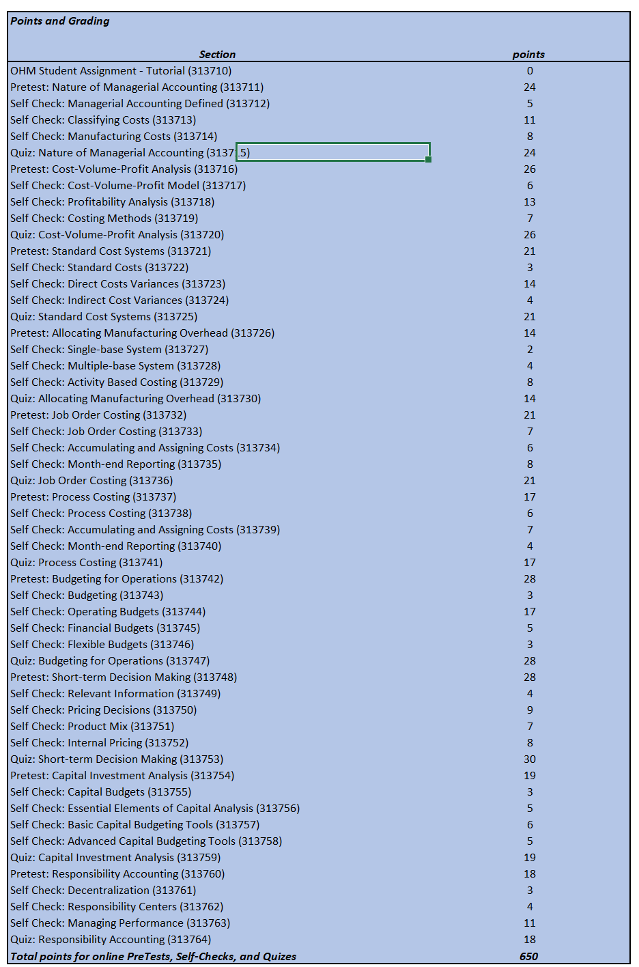

MIDTERM

- The Midterm will serve as a checkup of your progress. Also, it will give you an idea of what to expect on the final exam. The format will be a multiple-choice questions.

CASE STUDY

During the semester, we will be discussing one teaching case. A teaching case is basically a story that describes a real business situation faced by managers, employees, entrepreneurs, etc. Cases allow you to perform an analysis/evaluation and recommend a course of action for the protagonist of the case.

The instructions for the Case Study will be distributed through Canvas.

ONLINE RECORDINGS and GUEST SPEAKERS

To achieve the objectives outlined early in the syllabus, I have invited several accomplished speakers who will share their marketing experience in each of their industries. I will also use online recording as needed

Writing Standards

The standard of writing is that of an upper-division class, so you should have already achieved correct grammar and punctuation skills.

Cheating, Plagiarism and Other Forms of Academic Dishonesty

By enrolling at CSU Channel Islands, students are responsible for upholding the University's policies and the Student Conduct Code. Academic integrity and scholarship are values of the institution that ensure respect for the academic reputation of the University, students, faculty, and staff. Cheating, plagiarism, unauthorized collaboration with another student, knowingly furnishing false information to the University, buying, selling, or stealing any material for an examination, or substituting for another person may be considered violations of the Student Conduct Code (located at http://www.csuci.edu/campuslife/student-conduct/academic-dishonesty.htm). If a student is found responsible for committing an act of academic dishonesty in this course, the student may receive academic penalties including a failing grade on an assignment or in the course, and a disciplinary referral will be made and submitted to the Dean of Students office. For additional information, please see the faculty Academic Senate Policy on Academic Dishonesty, also in the CI Catalog. Please ask about my expectations regarding academic dishonesty in this course if they are unclear.

The Internet is an excellent source of information, and I encourage you to use it for research. However, do not copy another author's writing word for word, except for brief passages to support your thesis. When using another writer's work, accurately identify it with a proper citation.

Plagiarism or cheating on tests and exams will results in an "F" (0 points) on the tests or exams, very likely resulting in a lower or possibly a failing final grade in the course. No retakes. Plagiarism on homework or project deliverables will result in a 0-point grade for that document. In the case where the cheating or plagiarism was premeditated or planned, students may receive an "F" for the course. I encourage you to review this document from UC Davis to learn to distinguish between collaboration and plagiarism: http://www.academicintegrity.org/icai/assets/unauthorizedcollaboration.pdf.

Last semester students cut and pasted answers from Internet in the final exam. Let me make it clear: This is plagiarism. So please ask about my expectations regarding academic dishonesty in this course if they are unclear.

Disabilities Accommodations

If you are a student with a disability requesting reasonable accommodations in this course, please visit Disability Accommodations and Support Services (DASS) located on the second floor of Arroyo Hall, or call 805-437-3331. All requests for reasonable accommodations require registration with DASS in advance of needed services. You can apply for DASS services here. Faculty, students, and DASS will work together regarding course accommodations. Please discuss approved accommodations with me ASAP!

Civil Discourse Statement
All students, staff, and faculty on our campus are expected to join in making our campus a safe space for communication and civil discourse. If you are experiencing discomfort related to the language you are hearing or seeing on campus (in or out of classes), please talk with a trusted faculty or staff member. Similarly, please consider whether the language that you are using (in person or on Canvas) respects the rights of others to "engage in informed discourse and express a diversity of opinions freely and in a civil manner" (language from Academic Senate Resolution SR 16-01, Commitment to Equity, Inclusion, and Civil Discourse within our Diverse Campus Community).
In addition, students whose conduct adversely affects the learning environment in this classroom may be subject to disciplinary action. Students that disrupt this course may receive a verbal and written warning from the instructor, they may be excused from the class for the day, they may be excused from the class for up to one class period, and/or they may be referred to the Dean of Students office for further review and possible disciplinary action.
Counseling and Psychological Services (CAPS)
CAPS is pleased to provide a wide range of services to assist students in achieving their academic and personal goals. Services include confidential short-term counseling, crisis intervention, psychiatric consultation, and 24/7 phone and text support. CAPS is located in Bell Tower East, 1867, and can be reached at 805-437-2088 (select option two on voicemail for 24/7 crisis support; or text "Hello" to 741741); you can also e-mail us at caps@csuci.edu or visit https://www.csuci.edu/caps.
Title IX and Inclusion
Title IX & Inclusion manages the University's equal opportunity compliance, including the areas of affirmative action and Title IX. Title IX & Inclusion also oversees the campus' response to the University's nondiscrimination policies. CSU Channel Islands prohibits discrimination and harassment of any kind based on a protected status (i.e., age, disability, gender, genetic information, gender identity, gender expression, marital status, medical condition, nationality, race or ethnicity, religion or religious creed, sexual orientation, and Veteran or Military Status). This prohibition on harassment includes sexual harassment, as well as sexual misconduct, dating, and domestic violence, and stalking. For more information regarding CSU Channel Islands' commitment to diversity and inclusion or to report a potential violation, please contact Title IX & Inclusion at 805.437.2077 or visit https://www.csuci.edu/titleix/.

Business Program Advising Website
There are two types of class advising at CSUCI, academic advising and major/minor advising.
1. The Academic Advising (https://www.csuci.edu/academics/advising/) department helps students from all majors choose general education (GE) and other non-business classes. Please make an appointment with them to ask about GE and other non-business classes.
2. The major/minor advisors help you pick business classes. There are two business major/minor advisors who specialize in helping you choose classes for your business major or business minor. They can help you:
- check whether you are on schedule to graduate
- plan which classes to take each semester
- decide whether you want to declare an option in the business major
- plan which classes to take while studying abroad
- answer any other questions about the business major or minor
Please check this site for additional information related to the Business Program https://business.csuci.edu/businessadvising.htm

Disclaimer
The information contained in this syllabus, other than the mandated by the University, may be subject to change with advance notice.

